**Correction factors:**

1. Add 4 bottom menu on **About Us:** **Details,**

**History,**

**School Profile**

**School Management**

1. Please mention Principal message (with principal photo) on right side or left side of **Home page**
2. Insert the photos on **Gallery** headings
3. Mention the contact Number: 088- 412002, 9857844375 and email address: [jkhstharmare@gmail.com](mailto:jkhstharmare@gmail.com) on **Contact** heading
4. Remove the **Faculty** heading
5. 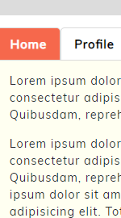Replace the **JFSS** instead of **Alumni** heading
6. Replace the heading of Home, Profile with NEWS and EVENTS heading at right side
7. Put the School logo in front of School name on top bar.
8. Keep the automatic displaying photos on Home page at the middle part.
9. Write the **HOME** heading instead of Home logo
10. Add **CAREER** heading at last
11. Mention the Janakalyan Former Student Society (JFSS) Committee name (File is attached)